Homework 2

1. Describe the basic architecture of a Wi-Fi network (components and functionalities).

Ans:

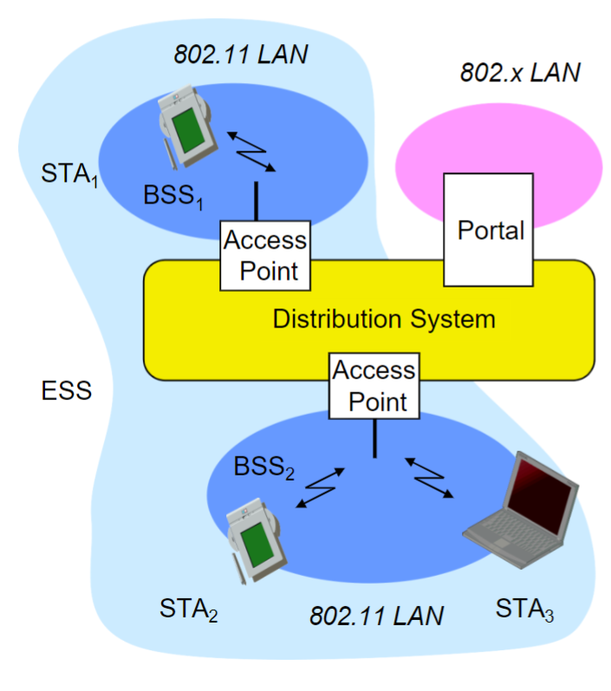

The basic architecture of WIFI network consists of the following:

* Station
* Access point
* Basic Service Set
* Portal
* Distribution system

**Station**: It’s the terminal with access mechanisms to the wireless medium and radio contact to the access point

**Access Point**: The station integrated into the wireless LAN and the distribution system.

**Basic Service Set (BSS):** BSS can be defined as the group of stations which are using the same AP.

**Portal**: It used as the bridge to other (wired) networks on internet.

**Distribution** **System**: The interconnection network to form one logical network is based on several BSS. Which is a combination multiple BSS and this is known as ESS. It stands for Extended Service Set.

This can be further divided into simpler and day to day used terminology in Wi-Fi network. They are:

* **Clients**
* **Access Points**
* **Wireless Router**
* **Wireless Antennas**
* **Wireless Controllers**
* **Ethernet Switches**
* **Gateway/Modem**
* **Cabling**
* **Security**

2. Explain Wi-Fi Connection/Disconnection process? Discuss all the steps involved in the

process.

Ans: The Wi-Fi connection and disconnection process involves several steps. They are as follows:

* **Scanning:** The device scans for available networks either passively or actively
* **Authentication**: The device uses WEP, WPA and WPA2 authentication mechanisms to exchanges authentication frames with the access point to verify compatibility and security protocols.
* **Association**: After the successful authentication, the device sends an association request to join the network and it sends an Association ID.
* **Notification**: Either the device or the access point (AP) may want to terminate the connection. This could be due to signal issues, user command, or device shutdown.
* **Disassociation**: Next the device or access point terminates the connection by sending a disassociation frame.
* **De-authentication**: This step is the final to end all communications, such as when an AP needs to reboot or a device stops Wi-Fi communications.
* **Acknowledgment**: This steps takes place when either client or router wants to end the connection normally when there is no signal loss or device shutdown, then receiving party acknowledges the disassociation frame, completing the disconnection process.

1. What advantages does Ad-hoc network offer? What are the design challenges in Adhoc network?

Ans:

**Advantages of Ad-hoc Networks**

**Flexible**: Ad-hoc networks doesn’t require any pre-existing infrastructure other devices like routers or access points.

**Cost-effective:** it’s costs less to set up, which makes it easier in remote or temporary locations.

**Scalable:** It’s easy to add new devices to the n/w without any changes.

**Robustness**: The network can still function even if one node fails in the network.

**Design Challenges in Ad-hoc Networks:**

**Dynamic Topologies:** The topology of the network keep changing frequently due mobile nodes that move in and out of the network.

**Security**: Having secure communications between nodes is more complex.

**Limited Power:** Nodes in the network may have limited battery power to wor.

**Scalable**: With the increase in the nodes leads to more collisions and signal interference.

**QoS:** Having a reliable data transmission without less or no delay is very hard.

**Overhead:** Having routing information will consume a lot of network's resources.

1. Differentiate proactive and reactive routing protocols. Write examples for each.

Ans:

Difference between proactive and reactive protocols are as follows:

|  |  |  |
| --- | --- | --- |
| **Feature** | **Proactive Routing Protocols** | **Reactive Routing Protocols** |
| **Route Discovery** | Maintain routes to all destinations in the network at all times. | Discover routes only when needed. |
| **Latency** | Lower latency since routes are pre-determined and maintained continuously. | Higher initial latency due to route discovery process. |
| **Overhead** | Higher overhead due to continuous route updates, which consumes bandwidth and power. | Lower overhead since routes are created and maintained only when necessary. |
| **Scalability** | Less scalable due to overhead in large networks. | More scalable, especially in networks where traffic patterns are dynamic. |
| **Network Knowledge** | Have complete knowledge of the network topology at all times. | Acquire knowledge of the network topology on an as-needed basis. |
| **Route Maintenance** | Routes are constantly updated, regardless of data transmission needs. | Routes are maintained only for the duration of a transmission session. |
| **Power Consumption** | Higher due to constant route updates and maintenance. | Lower, as energy is used mainly during route discoveries and maintenance for active routes. |
| **Usage Scenarios** | Suited for smaller networks with consistent traffic patterns. | Better for larger, dynamic networks with unpredictable traffic patterns. |
| **Examples** | includes OLSR, DSDV | includes AODV, DSR |

5. The figure below shows a weighted graph representing a network.

a. Each of the links in the graph has an associated weight. Given that the graph

represents a network, what could be the meaning of the link weights?

b. Starting from node A, manually compute Dijkstra’s algorithm and list the

obtained shortest-paths from u to each of the other nodes. For computing

Dijkstra’s algorithm, you can use the table as shown on the slides

c. Based on the shortest-paths from the previous task, derive the forwarding table

of node u.

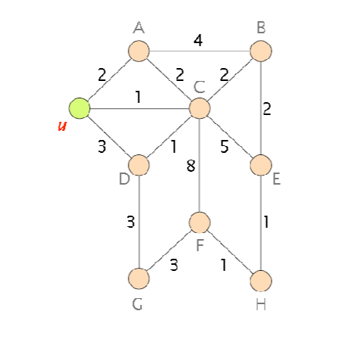

a. The values will be the cost or the distance between the nodes in the network. Which is used in the next question for desigining the routing table , finding the shortest path from source to destination.

b. Routing Table:

|  |  |  |  |  |  |  |  |  |  |
| --- | --- | --- | --- | --- | --- | --- | --- | --- | --- |
| **Step** | **N’** | **D(A)**  **P(A)** | **D(C)**  **P(C)** | **D(D)**  **P(D)** | **D(B)**  **P(B)** | **D(E)**  **P(E)** | **D(G)**  **P(G)** | **D(F)**  **P(F)** | **D(H)**  **P(H)** |
| 0 | U | 2,U | 1,U | 3,U | ∞ | ∞ | ∞ | ∞ | ∞ |
| 1 | UC | 2,U |  | 2,C | 3,C | 6,C | ∞ | 9,C | ∞ |
| 2 | UCA |  |  | 2,C | 3,C | 6,C | ∞ | 9,C | ∞ |
| 3 | UCAD |  |  |  | 3,C | 6,C | 5,D | 9,C | ∞ |
| 4 | UCADB |  |  |  |  | 5,B | 5,D | 9,C | ∞ |
| 5 | UCADBE |  |  |  |  |  | 5,D | 9,C | 6,E |
| 6 | UCADBEG |  |  |  |  |  |  | 8,G | 6,E |
| 7 | UCADBEGH |  |  |  |  |  |  | 7,H |  |
| 8 | UCADBEGHF |  |  |  |  |  |  |  |  |

Shortest path tree From U:

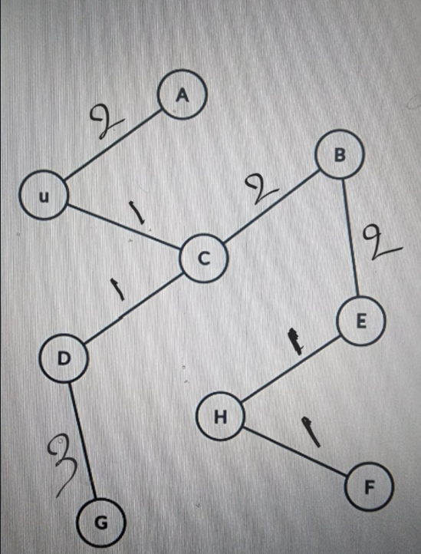

c. Forwarding table:

|  |  |
| --- | --- |
| Destination | Outgoing Link |
| A | U,A |
| B | U,C |
| C | U,C |
| D | U,C |
| E | U,C |
| F | U,C |
| G | U,C |
| H | U,C |

6. Describe the operation of the DSR (Dynamic Source Routing) protocol.

Ans:

Dynamic Source Routing (DSR) operates using reactive routing protocol in wireless ad hoc networks with prioritizing decentralization, flexibility, and efficient routing in dynamic conditions. There are mainly three main steps involved in DSR. They are as follows:

**Route Discovery**

* **Initiation** When a source required to send data to a destination but doesn’t have any existing route. It initiates route discovery for destination.
* **Route Request Packet**: The source broadcasts a packet with it’s and the destination's address along with a unique identifier, reaching out to neighboring nodes.

**Route Reply**

* **Receiving Nodes**: Nodes that receive the route request and know a path to the destination respond with a route reply packet.
* **Route Information**: This packet details the sequence of nodes between the source to the destination, enabling the source to determine potential routes.

**Route Maintenance**

* **Route Utilization**: The obtained route is used for sending data. Nodes along this path forward packets according to the route given in the reply.
* **Handling Failures**: If a link or node within the route fails, the failure of the node is communicated to the source, prompting it to select an alternative route from its cache or to initiate a new route discovery process.

**Characteristics:**

* **Decentralization:** DSR's operation is grounded due to no centralized control, with nodes determining dynamic routes.
* **Flexibility**: DSR can quickly adapts to dynamic changes in the network
* **Mobility Support**: Networks with frequent topology changes, DSR facilitates on-the-fly route establishment based on conditions.
* **Reduced Overhead**: Without need of continuous routing updates, DSR minimizes the network overhead.
* **Loop-Free**: DSR prevents routes to form loops due to it’s unique identification of each route request and by avoiding retransmission of identical requests.

Thus the operation of DSR is done in wireless ad hoc networks, which offers a robust framework for efficient and flexible routing with the challenges of mobility and network topology changes.